

(Accredited by NAAC & NBA, Approved By A.I.C.T.E., New Delhi, Permanently Affiliated to JNTU, Hyderabad)
(Aziz Nagar, C.B.Post, Hyderabad -500075)

Department of Computer Science and Engineering
(Artificial Intelligence and Machine Learning)

DEVOPS LAB
LAB PROJECT REPORT
TITLE: CivicLens - Civic Issue Reporter for Smart Cities
By
24915A6608 | D. HARSHA VARDHAN
24915A6610 | K. BHOOMA NAGI REDDY

Submitted to
Ms. G SUREKHA
Assistant Professor

CIVICLENS
1.OBJECTIVE
The primary objective of this project is to design and implement a simple, user-friendly Civic Issue Reporter web application for Smart Cities. The application enables citizens to report civic problems such as potholes, garbage dumps and broken streetlights with a photo and GPS location, and to track each report from Open to Resolved. The project also demonstrates a complete DevOps pipeline using Docker and Jenkins for building, testing and deployment.
2.TOOLS & TECHNOLOGIES
- Language: Python 3.11
- Framework: Flask 3.0 (REST API)
- Database: SQLite (file-based, persisted via Docker volume)
- Frontend: HTML, CSS, JavaScript with Leaflet maps
- Server: Gunicorn (production WSGI)
- DevOps & Testing: Docker, Docker Compose, Jenkins with pytest
- Browser: Chrome
3. INTRODUCTION
- This project focuses on building a simple, user-friendly Civic Issue Reporter web application using Python Flask and SQLite, with complete CRUD functionality and a live map to:
- Report civic issues with photo, category and GPS location
- View all reports on a searchable list and a live map
Update status (Open, In-Progress, Resolved) and upvote priority issues
- Handle form input and server-side validation
It reinforces core concepts such as:
REST API design (GET, POST, PATCH, DELETE)
SQLite database operations
Leaflet map integration
Containerization with Docker
CI/CD pipeline with Jenkins
4. CODE WITH PROJECT STRUCTURE
CivicLens/
├── app.py
├── templates/index.html
├── static/css/style.css
├── static/js/app.js
├── tests/test_app.py
├── requirements.txt
├── Dockerfile
├── docker-compose.yml
├── Jenkinsfile
├── seed_demo.py
└── uploads/
5. CODE REVIEW
5.1 Database Schema
CREATE TABLE issues (
id TEXT PRIMARY KEY,
title TEXT NOT NULL,
description TEXT NOT NULL,
category TEXT NOT NULL,
latitude REAL NOT NULL,
longitude REAL NOT NULL,
address TEXT NOT NULL,
status TEXT DEFAULT 'Open',
upvotes INTEGER DEFAULT 0,
image_path TEXT,
created_at TEXT NOT NULL,
updated_at TEXT NOT NULL
);
5.2 Database Operations
POST /api/issues – Submit a new report
GET /api/issues – List and filter reports
PATCH /api/issues/<issue_id>/status – Update status
POST /api/issues/<issue_id>/upvote – Add a priority vote
init_db() – Creates the issues table
list_issues() – Fetch all issues with filters
create_issue() – Add a new issue with validation
update_status() – Change Open / In-Progress / Resolved
upvote_issue() – Increment priority votes
delete_issue() – Remove an issue and its photo
get_stats() – Totals by status and category
5.3 API Endpoints
@app.route("/api/issues", methods=["POST"])
def create_issue():
data = request.get_json(force=True, silent=True) or {}
title = str(data.get("title") or "").strip()
description = str(data.get("description") or "").strip()
category = str(data.get("category") or "").strip()
if errors:
return jsonify({"errors": errors}), 400
issue_id = uuid.uuid4().hex[:8]
db = get_db()
db.execute("INSERT INTO issues (...) VALUES (...)", (...))
db.commit()
return jsonify(...), 201
@app.route("/api/issues/<issue_id>/status", methods=["PATCH"])
def update_status(issue_id):
new_status = str(data.get("status") or "").strip()
if new_status not in STATUSES:
return jsonify({"error": ...}), 400
db.execute("UPDATE issues SET status = ? ...")
db.commit()
return jsonify(...)
@app.route("/api/issues/<issue_id>/upvote", methods=["POST"])
def upvote_issue(issue_id):
db.execute("UPDATE issues SET upvotes = upvotes + 1 ...")
db.commit()
return jsonify(...)

6. EXECUTION STEPS
- Install Docker Desktop and start it.
- Clone the repository and open the project folder.
- Run: docker compose up -d --build.
- Open Jenkins at http://localhost:8080 and build the civiclens-pipeline job.

Run: http://localhost:5000 to use the application.

7. OUTPUT SCREENS
- Home Page – Service header, live counters and report list
- Map View – All reports pinned on a live map with status colours
- Report Modal – Form with photo, category and GPS location
Detail Modal – Full report with upvote and status controls
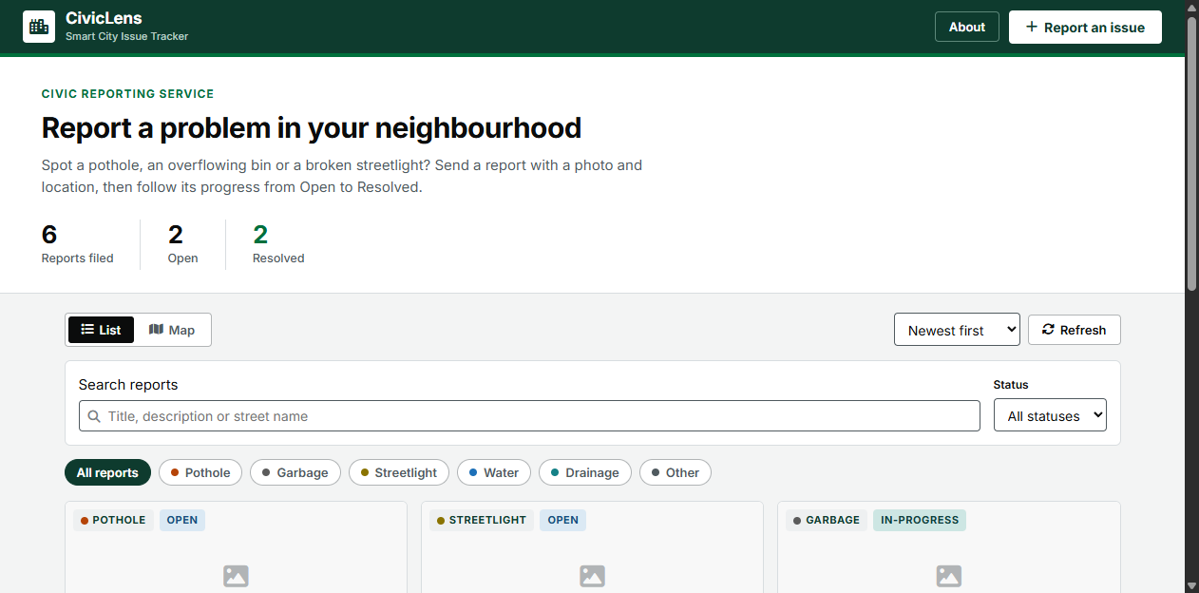

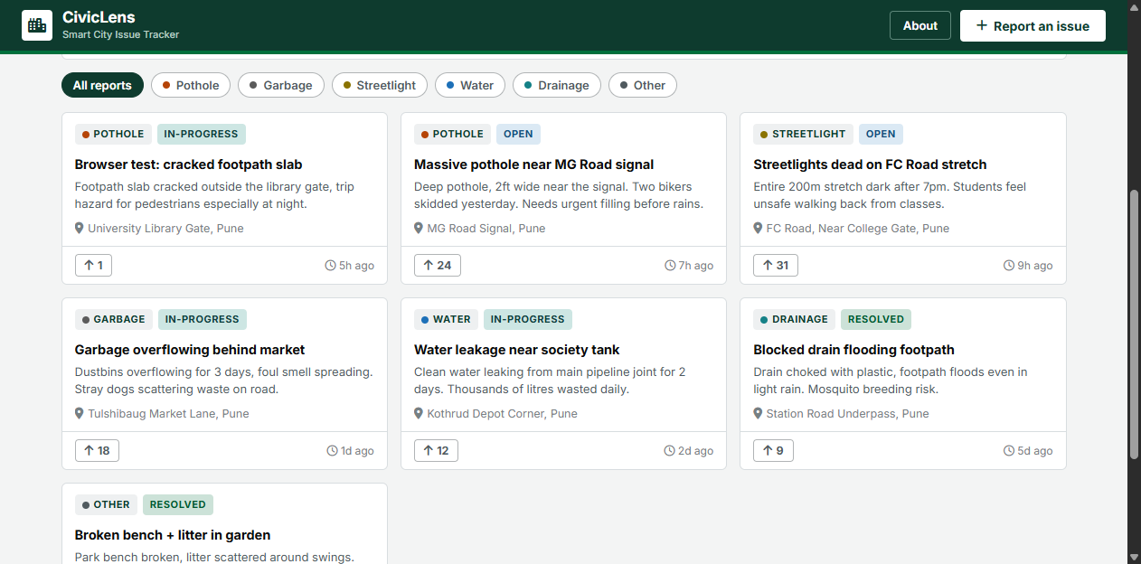

8. APPLICATIONS
- Municipal Corporations – Ward-level complaint tracking
- Smart City Missions – Citizen grievance dashboards
- Resident Welfare Associations – Locality maintenance reports
- College Campuses – Hostel and facility issue reporting
- NGOs – Civic cleanliness and awareness drives
General Public – Reporting issues in their neighbourhood

9. CONCLUSION

This implementation demonstrates how to build a real-world civic reporting application with Python Flask and SQLite, fully containerized with Docker and deployed through a Jenkins CI/CD pipeline. Every code change passes through automated tests before deployment, which is the core practice of DevOps.

Future Scope
- Add admin authentication and role-based access.
- Migrate to PostgreSQL with map-based duplicate detection.
- Add Prometheus metrics and a Grafana dashboard.

